stART Workshop Booking Form

Note to Teacher-in-charge:
- Please submit the completed registration form to the Gallery at outreach@nationalgallery.sg at least 45 days prior to the preferred date of your school visit or participation in any onsite or online learning programmes.
- The Gallery will contact the teacher-in-charge within 10 working days from the receipt of the completed registration form.
- Please read and acknowledge agreement to the Terms & Conditions by endorsing this registration form with your signature on the page overleaf.
- All school visits are only confirmed upon email confirmation from the Gallery.

By filling up and submitting this form, I hereby give National Gallery Singapore the consent to collect, use and disclose the personal data in this form for the purposes of administering the education programmes.

SECTION A: SCHOOL & BILLING INFORMATION
Name of School/Institution:

School/Institution Address: | School Contact Number:
Name of Principal or Vice Principal: | School Email Address:
Email Address of Principal or Vice Principal: | School Sub-BU Code/ UEN No:
Ministry or Statutory Board: | Department:
Attention to: | Address of school:  (if different from above)

SECTION B: CONTACT DETAILS OF PERSONNEL-IN-CHARGE
 | Name | Designation | Email Address | Contact No. (for emergency use)
1st Teacher-in-charge
2nd Teacher-in-charge

(Refer to Annex A – 2025 stART Workshop Booking Slots for list of programme slots available)
SECTION C: REGISTRATION
Educational Level(s) / Age | Subjects/  Groups/  Clubs  (if applicable) | Preferred Slot(s) |  | Venue for workshops in school  (for Sessions 1, 4, 5, 6) | No. of Pax
 |  | Option  1 | Option  2 |  | Students | Teachers
 | Arts Club / Gear-up / Student Leaders / Others: ________________________________ |  |  | *We recommend using the Art Room instead of Recreation Room for a more conducive workshop experience.
Does your student require additional support or access arrangement?
¨ Yes ¨ No

If your answer is “Yes”, please indicate below.
¨ ADHD ¨ Autism ¨ Down Syndrome ¨ Dyslexia
¨ Physical Difficulties ¨ Sensory Difficulties
¨ Speech Difficulties ¨ Emotional Disturbance
¨ Hearing Impairment ¨ Visual Impairment
¨ Other SEN or health concerns: Click or tap here to enter text.
(Please use a separate attachment if necessary).

SECTION D: TERMS AND CONDITIONS FOR TEACHERS WHEN MAKING SCHOOL BOOKINGS TO VISIT THE NATIONAL GALLERY SINGAPORE
- Registration
Schools need to register for school visits at least 45 days before the preferred date of their visit or programme.

- Confirmation
All school visits are only confirmed upon receipt of the email confirmation from the Gallery, subject to the availability of time slots and facilitators.

- Cancellation
Schools will have to bear a minimum administrative fee of S$100.00 for any programme cancelled within 30 days prior to the commencement of the school visit or programme. In the unlikely event of any unforeseen circumstances, the Gallery reserves the right to cancel programmes at its own discretion. However, the Gallery will not bear responsibility for any costs that the school might have incurred.
- Punctuality
Schools will have to ensure that punctuality is observed. Should schools arrive late for the programme, the programme may be modified or omitted to ensure that it ends by the time stated in the confirmation email.

- Rescheduling
To reschedule any programmes, schools must first cancel their existing bookings before placing new bookings in the booking system. The new bookings must still adhere to the minimum notice period of 45 days prior to your preferred programme date.

- No-Shows
In the case of a no-show by the school on the actual day of the school visit or programme, a minimum administrative fee of S$300.00 per programme will be chargeable to the school. A school is considered a ‘no-show’ they are more than 15 minutes late without any notification.
- Transportation Cost
Schools shall bear the costs of transport arrangements for their students to and from the respective venues.

- Parental Consent
Schools must ensure that written parental consent has been obtained for all participating students in the registered programme, where applicable.

- Attire
Students should be in attire endorsed by their respective schools, unless otherwise stated in the programme description.

- Teacher to Student Ratio
The ratio of the number of accompanying teachers/parent-volunteers/teacher-aides to students should be maintained as reflected in the table.

Education Levels | No. of Adult Chaperons | No. of Students
Pre-school | 2 | 30
Primary School | 2 | 40
Secondary Schools and Post-secondary Education Institutions | 2 | 40

- Gallery Etiquette
- Teachers and/or education facilitators must always accompany their students during school visits.
- Please ensure students refrain from touching any artefacts on open display. Touching artefacts, paintings, or works is strictly prohibited.
- All photographs must be taken without flash, as strong lights can damage sensitive materials such as paper and textiles.
- Do not lean on showcases and avoid rowdy behaviour in the Gallery.
- Please bring only dry writing materials, such as wooden 2B pencils, into the Gallery. Mechanical pencils and erasers are not permitted, as eraser dust can potentially damage the artworks.
- Food and drinks can only be consumed in designated areas advised by the education officers via email or during your visit.
- For self-guided tours, schools are advised to return to an artwork if it is crowded. Flexibility with your itinerary is strongly recommended in such circumstances.

- Responsibility
Teachers should always consider themselves responsible for the behaviour of their students during the onsite and/or online learning experience from the Gallery.

- Waiver of Liability
Schools shall ensure the safety, well-being and behaviour of their charges at all times. The Gallery shall not be responsible or liable in any way for any loss, injury, mishap (including personal injury) of any students and/or teachers incurred during any onsite or online learning experience, provided always that such claims, liability, demands and causes of action of whatever kind do not arise out of or in relation to the negligence of the Gallery its staff, officers, faculty, or any of its authorised agents. Schools are required to conduct their own risk-assessment (RAMS) before arriving at the Gallery.

- Photographic, Audio or Video Recordings
Photographs and audio and video recordings may be taken during the Programme for the Gallery’s use. By participating in this programme, schools are allowing consent for the use of images and/or audio or video recordings as deemed fit by the Gallery. However, the Gallery will seek official permission from schools prior to the use of such images and/or video recordings.

- Confidentiality
This document shall not be reproduced or transmitted, whether in whole in part, in any form or by any means, electronic or mechanical, including photocopying, recording, or by any information storage and retrieval system without prior express written permission of the National Gallery Singapore.

*National Gallery Singapore reserves the right to make changes to the artwork and modifications to the programmes without prior notice.

Please tick to acknowledge the following statements.

- By filling up and submitting the online booking, I hereby give National Gallery Singapore the consent to collect and use of teachers’ contact details: name, school, contact number, and email for the purposes of administering the education programmes.

- By filling up and submitting the online booking, I accept and agree to all terms and conditions stated in this document.

Name of Teacher-in-charge:

Signature of Teacher-in-charge:

Date:

Strength Through Art Workshop
No. of sessions: 6 sessions (2 at National Gallery Singapore, 4 in school)
Duration: 2 hours/session
Cost per participant: $168/pax (before GST)
*This is a NAC-AEP programme and eligible for subsidy under the Tote Board Arts Grant. (click here for more info)
No. of participants/group: 12 – 15 pax/group
(Max. 2 groups of 12 – 15 participants)
Recommended age: 13 and up
For noting
- It is important for at least 1 teacher/counsellor per group to be present for every session
- Do encourage participants to have their lunch before the sessions
- No. of participants to be confirmed at least 1 week before session 1
- Payment will be billed after the last session of the programme and based on final confirmed no. of participants
- Programme cost includes the provision of programme Playbook and art materials
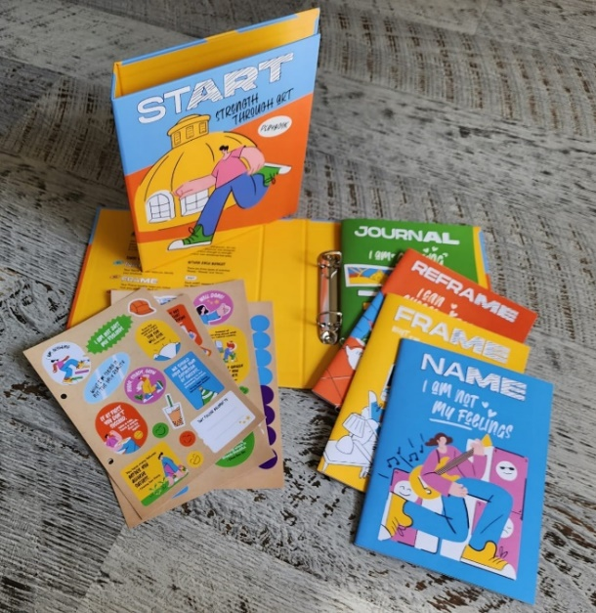
- School to arrange and cover transportation to National Gallery Singapore for session 2 and 3
- Teachers/counsellors are responsible for managing classroom behavior
- Teachers/counsellors are encouraged to participate in the activities

